# NAME: VINIT KUMAR

# SAPID : 590029353

# BATCHNO :78

# COURSE : B – TECH COMPUTER SCEINCE

EXPERIMENT -3

# BASIC SYNTAX

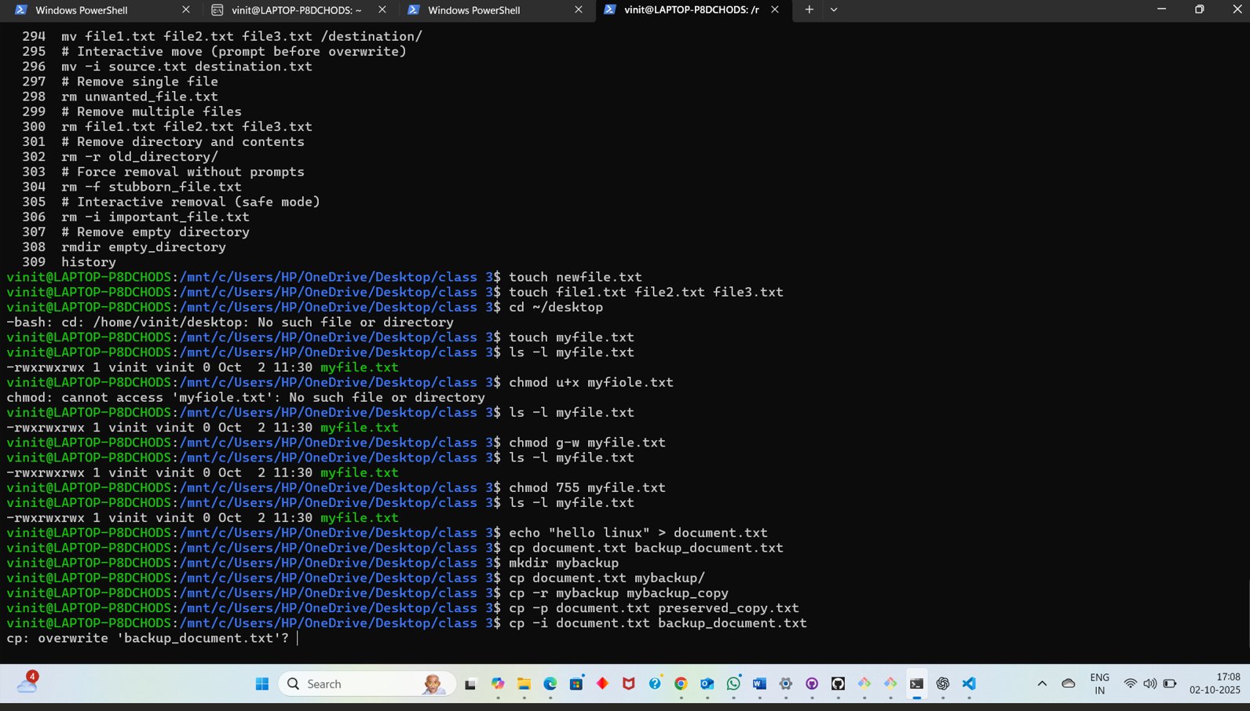

## 

## EXPERIMENT -4

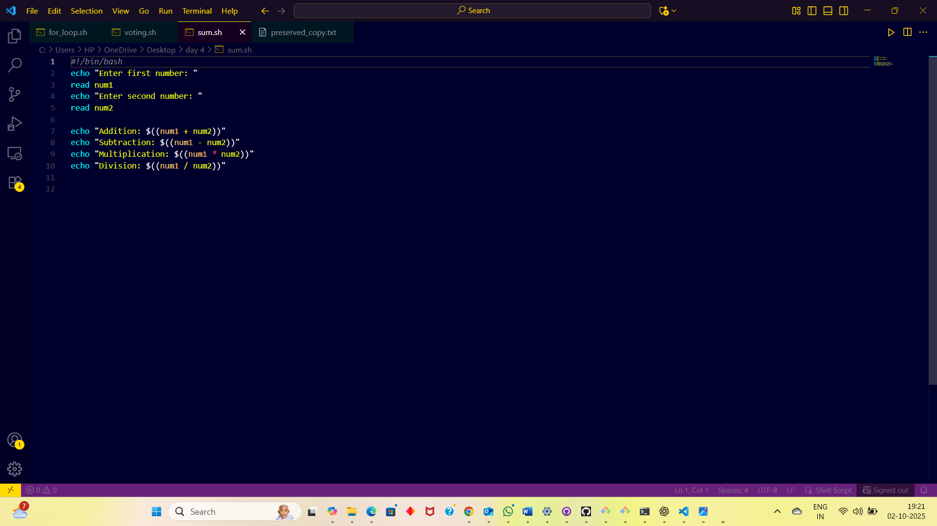 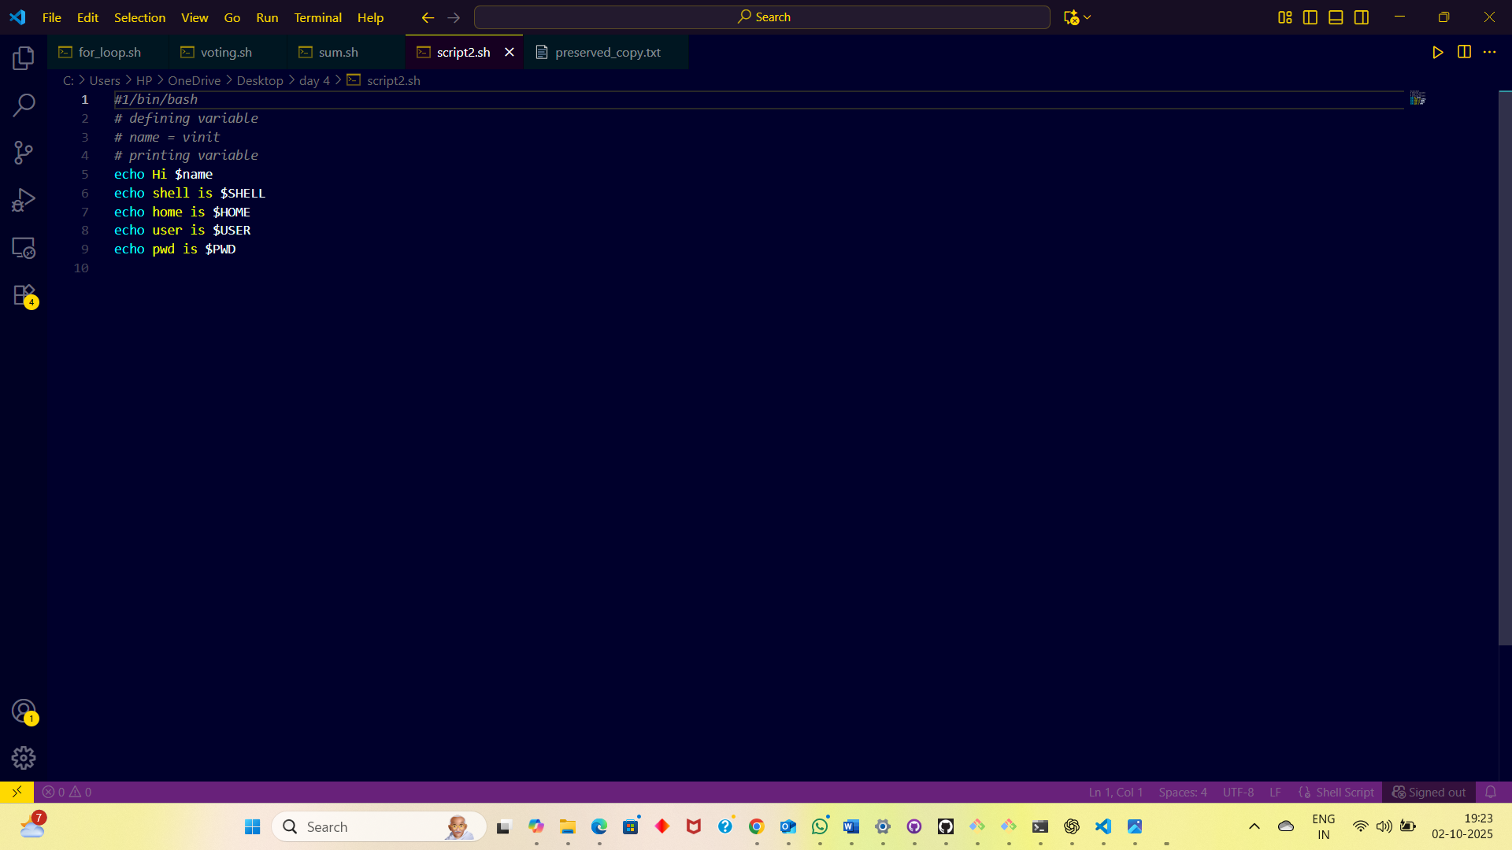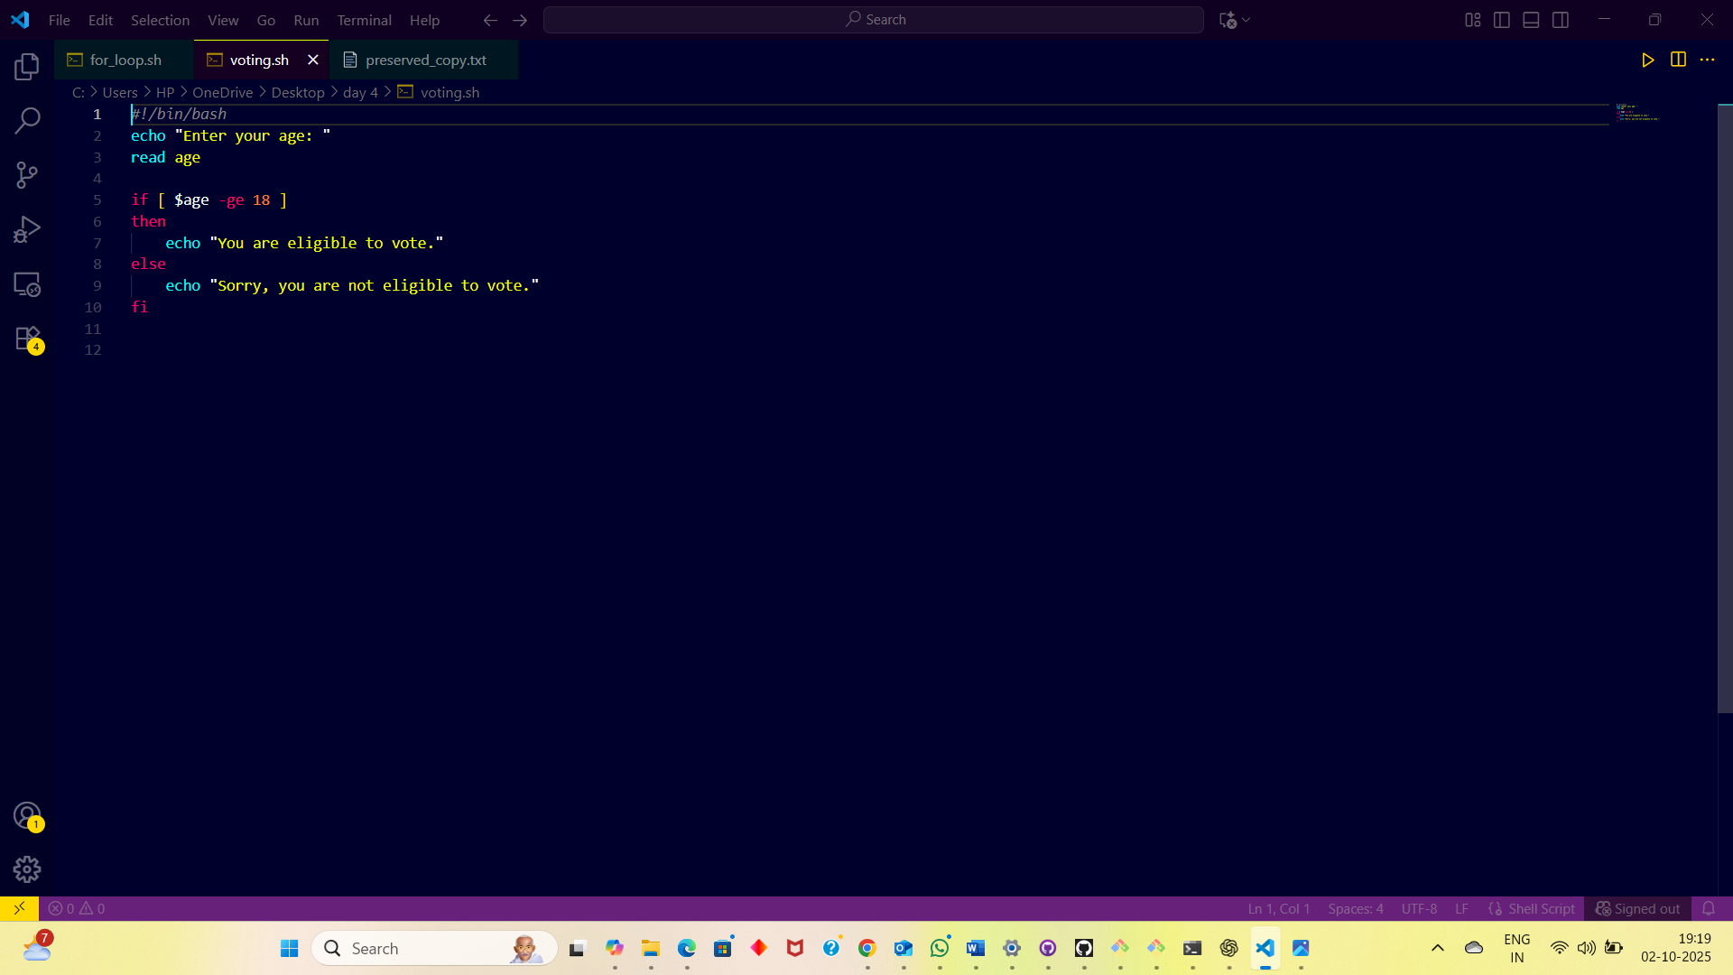

# EEEX

# EXPERIMENT-6

# A computer screen shot of a black screen AI-generated content may be incorrect. A screenshot of a computer AI-generated content may be incorrect. A screenshot of a computer AI-generated content may be incorrect. A screenshot of a computer AI-generated content may be incorrect. A screenshot of a computer AI-generated content may be incorrect. A screenshot of a computer AI-generated content may be incorrect. A screenshot of a computer AI-generated content may be incorrect. A computer screen with a dark blue background AI-generated content may be incorrect. A screenshot of a computer AI-generated content may be incorrect.

# EXPERIMENT-7

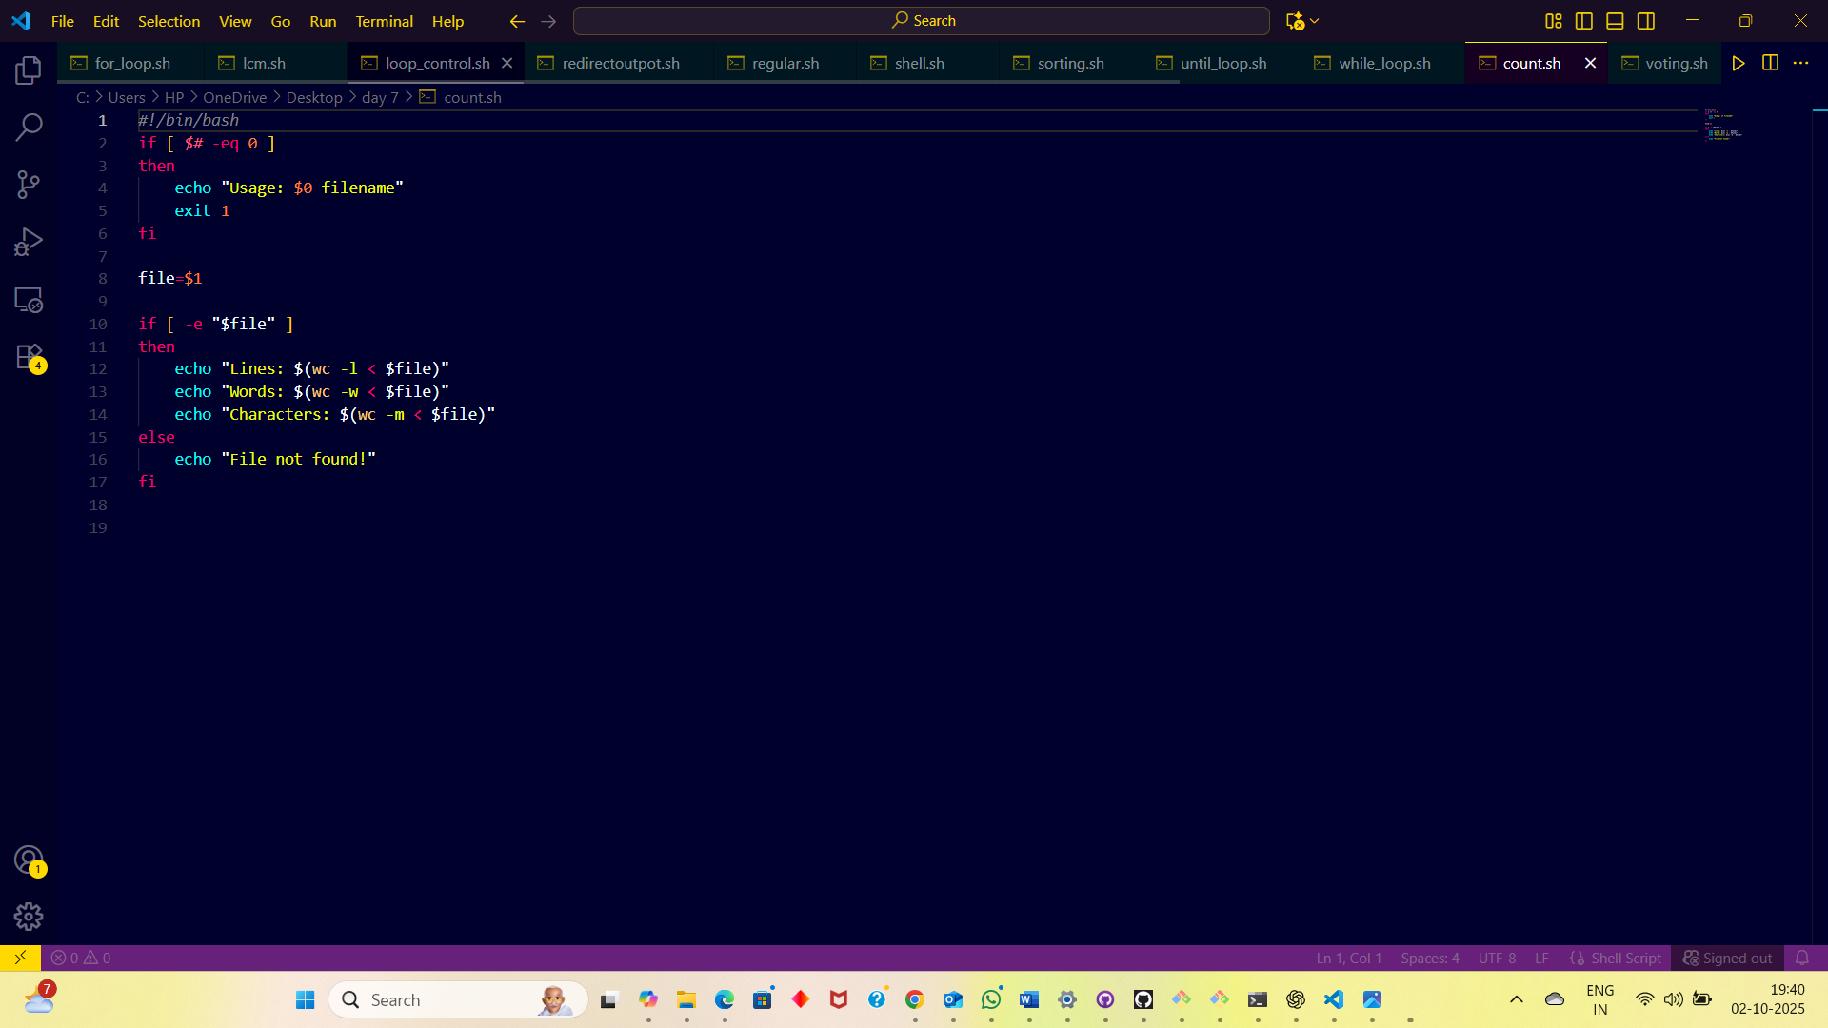

# EXPERIMENT-8

